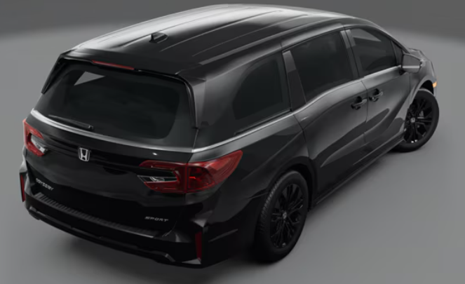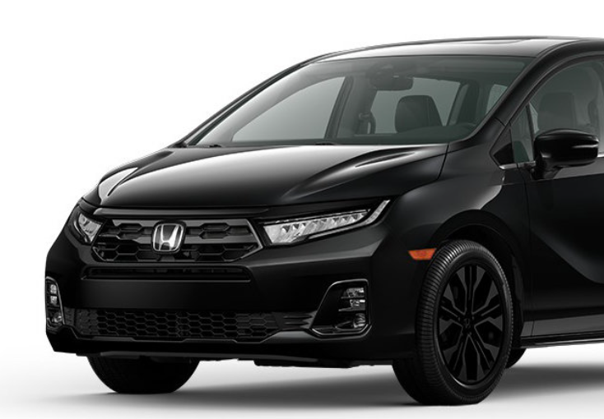

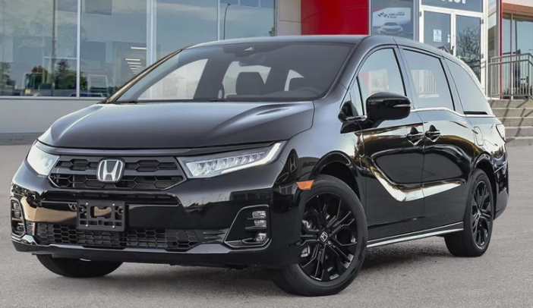

Main Specification of Honda Odyssey

**🚗 Powertrain & Performance**

| **Feature** | **Specification** |
| --- | --- |
| **Engine** | 3.5 L SOHC i‑VTEC V‑6 (J35Y6) |
| **Displacement** | 3,471 cc (212 cu‑in) |
| **Horsepower** | 280 hp @ 6,000 rpm |
| **Torque** | 262 lb‑ft @ 4,700 rpm |
| **Transmission** | 10‑speed automatic (front-wheel drive) |
| **Fuel Economy (EPA)** | 19 mpg city / 28 mpg highway / 22 mpg combined |
| **Fuel Tank Capacity** | 19.5 gal |

**📏 Dimensions & Capacities**

* **Overall Length**: 205.2 in
* **Width (w/o mirrors)**: 78.5 in
* **Height**: 69.6 in
* **Wheelbase**: 118.1 in
* **Curb Weight**: ~4,526 lb (~2,053 kg) **Interior Space**
* **Seating Capacity**: 8 passengers
* **Legroom**:
  + Front: ~40.9 in
  + 2nd row: ~40.9 in
  + 3rd row: ~38.1 in
* **Cargo Volume**:
  + Behind 3rd row: 32.8 cu ft
  + Behind 2nd row: 86.6 cu ft
  + Behind 1st row: 140.7 cu ft

**🛠️ Drivetrain & Suspension**

* Front-wheel drive
* **Suspension**:
  + Front: MacPherson struts
  + Rear: Multi-link trailing arms
* **Brakes**:
  + Front: Ventilated disc (12.6 in)
  + Rear: Disc (13 in)
* **Wheels/Tires**: 19″ alloys, 235/55R19 (some trims offer 18″)

**🔒 Towing & Efficiency**

* **Towing Capacity**: 3,500 l
* **Emission Rating**: LEV3‑ULEV70

**🧰 Features & Technology**

* **Instrument Display**: 7″ digital gauge cluster
* **Infotainment**:
  + Standard 9″ touchscreen
  + Wireless Apple CarPlay & Android Auto
  + Wireless charging
  + Multiple USB‑C ports (up to 6 on higher trims)
  + Touring/Elite get a 12.8″ high-res screen
  + HDMI port, cabin PA system

**🌟 Safety & Driver Assistance**

* **Honda Sensing®** suite includes:
  + Adaptive cruise control with lane centering
  + Lane‑keeping assist
  + Blind‑spot & rear-cross traffic alerts
  + Traffic sign recognition
  + Automatic emergency braking & high beams
* Additional: multiview camera, parking sensors (on Touring/Elite
* **Crash Ratings**: IIHS Top Safety Pick+, 5-star NHTSA rating, lowest driver death rate in class

**🎯 Summary**

The 2025 Odyssey remains a robust, spacious minivan powered by a refined 3.5 L V‑6 and a 10-speed auto. It offers generous seating and cargo space, competitive fuel economy, and a strong tow rating. Tech upgrades include a digital dash, upgraded infotainment, and refreshed styling. Safety is top-tier, with the full Honda Sensing® suite and excellent crash test results.